Missed work for Thursday March 18, 2021
- Science – we learned about the pitch of sound
  - Watch the video called “High pitch and low pitch” on my website in the science section
  - Use a ruler and elastic band to try the activities on the sheet below
  - Copy the notes below into your science duotang
- Reading workshop – we learned about strategies to use when you don’t understand a word during reading, try to notice what you do when you are reading an unknown word
- Math – we learned about division with remainders by dealing out
  - Do Jump pages 150-151
  - You will do a check-up quiz when you get back to school
Other
- Study for your memory verse and spelling test
- We had our free class last period, check out the video on Seesaw
- We finished reading Shiloh today, the kids said it was a 4+!
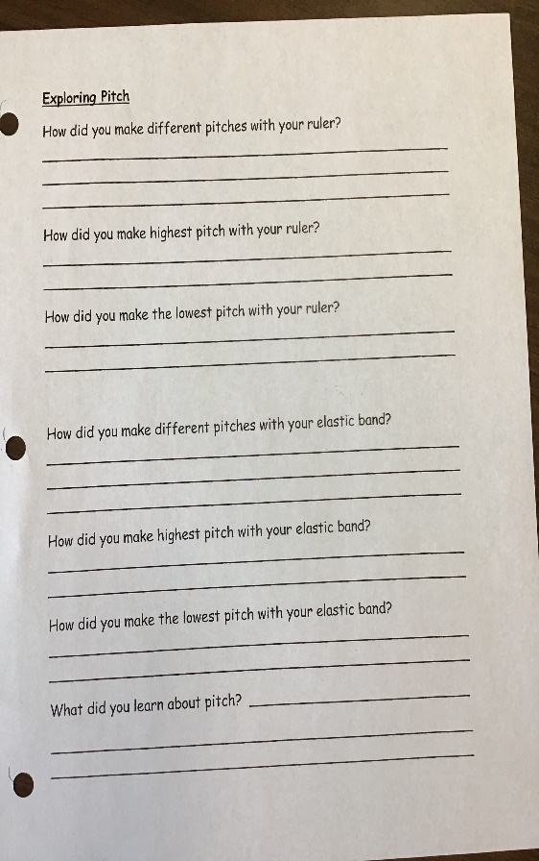
- See you all soon!
