**Missed work for Wednesday May 12, 2021** : Markus

**Social studies** – we learned about SK crops and reviewed for the coming test

* Read the info sheets I sent photos of titled “Crops Grown on SK Farms” (on Seesaw)
* print the organizer below “What are SK Crops Used For?”, Use the sheets to complete the organizer
* Print the review sheet below, study for the test on Friday

**Writing Workshop** – we learned about descriptive paragraphs

* Think of 5 describing words you put in front of each these words : apple, puppy, road, school
* Finish drafting your descriptive paragraph about a place, ask mom to read it to make sure it isn’t a story (narrative) or information (expository) but simply describing a place
  + Remember to underline your possibly missed words as you draft, so you can check them later

**Math** – we learned about solving fraction word problems

* Do Jump page 34 (you missed the teaching but ask your parents to help you if you get stuck)

**Word Workshop** – we practiced when to use to, too, two

* Play the “too to two its it’s” game on the words page of my website

**Other**

* We had chapel today
* We spent an hour planning our video chapel
* Spelling test, memory verse and x test tomorrow (Thursday)
* Study for social studies test Friday
* Miss you!

**C:\Users\bp712\AppData\Local\Microsoft\Windows\Temporary Internet Files\Content.IE5\0LFL0ESU\MC900290574[1].wmfWhat are Saskatchewan Crops used for???**

|  |  |
| --- | --- |
| **Flax** | **Sunflowers** |
| **canola** | **mustard** |
| **wheat** | **oats** |
| **rye** | **Canary seed** |
| **barley** | **legumes** |
| **Peas and lentils** | **Wild rice** |

**Social Studies Review Guide: Natural Resources of SK**

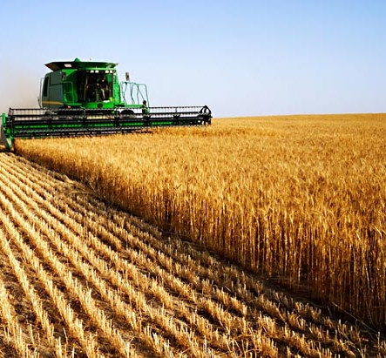

**What should I know for the test?**

1. natural resources of SK

* what they are
* what they are used for
* renewable and non-renewable

2. industries in SK

* what is an industry
* what are the different ones in SK
* how do they help people
* what NR they use

3. how industries help the economy

* what economy means
* jobs in industries, which industries employ the most people in SK

4. how industries use technology

* examples of this

5. the potash industry

* what potash is and is used for
* how potash is taken out of the ground

6. the agriculture industry in SK

* what is agriculture
* why it is our most important industry
* types of farms in SK and what they produce
* types of crops grown in SK

**How should I study?**

* Read your notes
* Write a pretend test for yourself
* Have your parents ask you questions
* Make a web of the big ideas
* Jot note what we learned
* Don’t study just the morning of the test