**Missed work for Tuesday May 11** : Markus 😊

**Social Studies** – we reviewed kinds of SK farms and learned about SK grains

* I can’t really send home what we did today : we played a review game and did a seed identification activity
* Please print the sheets below, that review home learning. Hole punch them, add to your duotang then read them. Hilite and underline important things.

**Writing Workshop** – we relearned how to write a descriptive paragraph

* Read the descriptive paragraph example I sent you on Seesaw, notice how it is not narrative or expository
* Choose a place to write a descriptive paragraph about (example : a library, a deserted town, an old barn, a bedroom, etc.)
* Draft, revise and edit a descriptive paragraph about the place you choose (3/4 to a full page)

**Math** – we reviewed fractions by meeting in pairs to check over all the assignments kids did at home

* Ask a parent to check all pages 19-33 in your Jump book and correct any errors

**Other**

* The kids had music today
* We started a school contest to see which classes are doing the best job of following Covid rules at school, the winning class gets pizza each Friday! Our class did great today!
* We miss you Markus!

**Industries Use Technology to Help Them Deal With Natural Resources**

Examples…

Manufacturing Industry

* computers that are used to design farm equipment at CNH or John Deer
* milk nozzles that fill jugs of milk in Dairyland
* conveyor belts that keep parts moving in assembly lines

Agriculture Industry

* GPS used in combines to keep them driving straight
* equipment such as tractors, air seeders, combines, sprayers, etc.
* cow milking machines

Communication Industry

* cell phones
* satellite television
* newspaper printing machines

Forestry Industry

* chainsaw
* machines that cut bark off tress and cut wood into lumber
* branch stripper machines

Construction Industry

* hand tools such as air nailers, power drills, skill saws, etc.
* concrete mixers and trucks
* computer designers for blue prints of buildings

Tourism Industry

* paintball guns
* motor boats
* quads and motorcycles

Transportation Industry

* airplanes, trains, busses
* vehicles : cars, trucks, SUVs
* on-line booking for tickets

Mining Industry

* coal plow
* elevators in mines
* heavy duty hauling trucks

Fishing Industry

* motorized boats
* electronic depth sensors
* swivel fishing chairs in boats

Trapping

* humane trapping devices

Utilities Industry

* pipelines for bringing water, sewer and gas to homes
* computerized billing
* natural gas furnace

**Economy in Saskatchewan**

The word “economy” means the way a place uses its resources to make money. SK’s economy is good when there are many jobs, industries and money being spent.

How do people make money in SK?

14% have jobs in agriculture

7% have jobs in manufacturing

3% have jobs in mining

76% have jobs in the service industry

**Types of Farms in Saskatchewan**

**Mixed Farms**

* Some animals and some crops to produce some meat and some grains
* Most common farm in early SK, not as many now
* Farmers are busy year round

**C:\Program Files\Microsoft Office\MEDIA\CAGCAT10\j0233312.wmfGrain Farms**

* Grow crops to produce grains
* Wheat, barely and oats are the most common
* Also grow peas, chickpeas, lentils, canola, flax, sunflower, mustard
* Most busy times are spring for seeding and fall for harvesting

**Dairy Farms**

* Produce milk
* Average number of cows on a farm is 148
* Milk is made into a variety of dairy products after it leaves the farm such as better, cheese, cottage cheese, yogurt and ice cream

**Beef Cattle Farms**

* Produce beef meat
* SK produces the second largest amount of beef in Canada
* 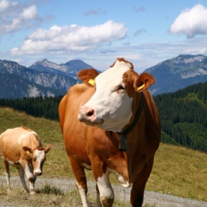Some farms are called feedlots as cows are brought to them to just be fed and fattened up before slaughter

**C:\Documents and Settings\bp712.SPIRIT.120\Local Settings\Temp\Temporary Internet Files\Content.IE5\PRHJFNMQ\MC900030348[1].wmf**

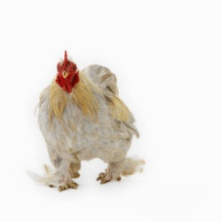**Poultry Farms**

* Produce either : chickens that lay eggs, meat chickens, turkeys or ducks& geese
* Breeder farms have chickens that lay eggs that will hatch into chicks
* Hatcheries are farms where eggs are warmed until they hatch into chicks
* Broiler farms raise chickens to be slaughtered for meat
* Egg farms have laying hens that produce eggs for us to eat

**Specialty Farms**

* Focus on growing products that are not common in SK
* C:\Documents and Settings\bp712.SPIRIT.120\Local Settings\Temp\Temporary Internet Files\Content.IE5\PRHJFNMQ\MC900090218[1].wmfThese farms can produce : berries, herbs, Christmas trees, wild rice, bedding plants, potatoes, bison, elk, wild boar, deer, ostrich, emu, rhea, organic grains and meat
* Organic products are becoming more popular around the world

**Wild Rice Farms**

* 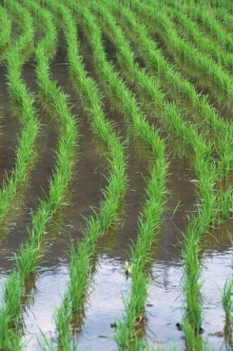Produces wild rice which is really a grass, not rice at all
* Mostly in northern SK because the conditions are good for it there, it grows along marshes and shores of rivers and shallow lakes
* Planted by throwing seeds onto the water