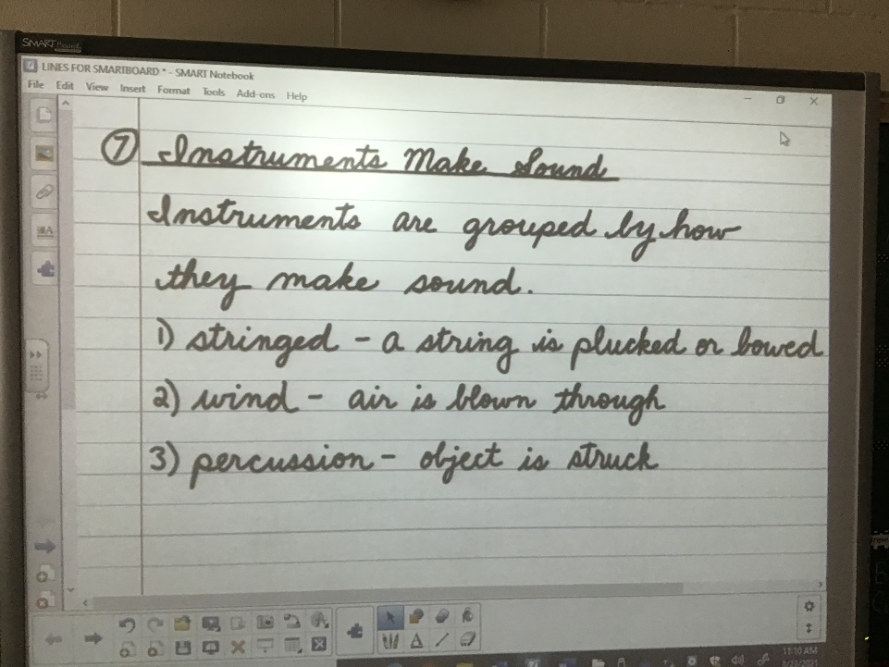
Missed work for Tuesday March 23, 2021
- Science – we learned about how instruments make sound
  - Watch videos #1 and 2 What can you learn about these groups : stringed, wind and percussion instruments?
  - Copy the science notes beside here
  - Label each instrument on the handout that came home today with which group it fits into of the 3 kinds above
- Writing workshop – we learned about adding details to an organizer list of events for a narrative paragraph
  - Draft your non personal narrative paragraph (minimum 1 page, maximum 2 pages)
- Math – we learned about more strategies to divide
  - Do any corrections your parents might find on page 154 in your jump book
  - Learn the strategy at the top of page 155 and do page 155 questions
- Christian Ethics – we learned about the Last supper
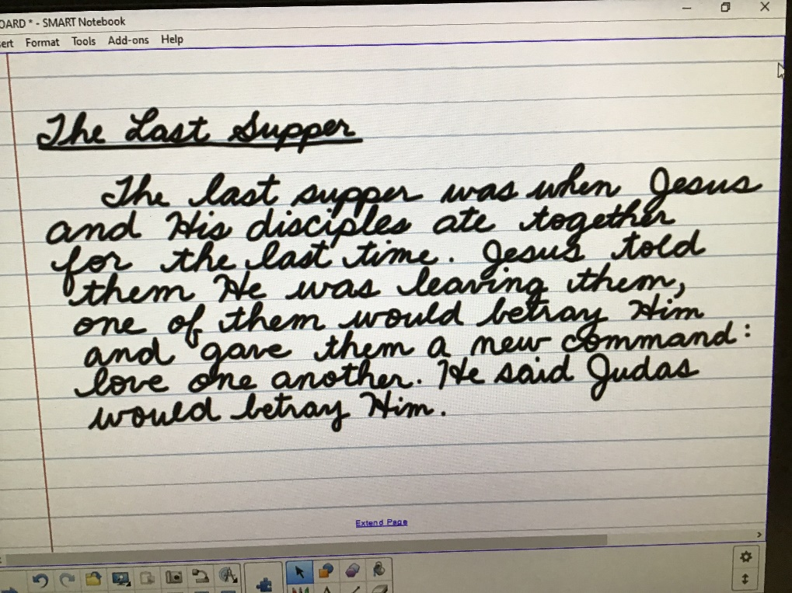
  - Finish both sides of the Last supper worksheet
  - Copy this paragraph into your Easter booklet
  - Finish coloring your booklet cover
Hope to see you tomorrow!!
Mrs. Priebe

