Missed work for Tuesday Feb. 9
Math
- Think about using doubles to multiply small and large numbers
- Do Jump page 122-123 (follow the examples, the bonus Q is optional)
Research Project (a big part of our day that we will be working on Tuesday and Wednesday… goal is to finish Wednesday)
- Write the good copy of your interesting facts paragraph from yesterday (use the lines behind)
- Read the example below then write a conclusion paragraph for your habitat report on a new piece of white paper (use the lines behind)… get your parent to check your revising and editing so all corrections are done
- Complete the cover for your report
  - Include your name, a title, pictures and color (pencil crayons)
  - You may use drawings and/or computer photos glued in
- Work on illustrations/computer photos for your information pages
Other
- Bring all materials and work back when you return to school
- You missed a real fire alarm on Monday, lots of excitement! (but there wasn’t a real fire, just a problem in the IA room)
- We miss you, hope you can make it back soon!

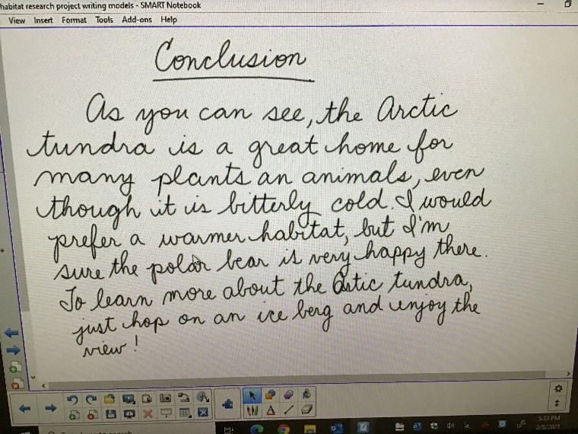
example for a conclusion paragraph : no new info, just a fun wrap up of the habitat, not very long but at least 3 sentences

