Missed work for Thursday April 15, 2021 : William
Reading Workshop – making connections
- Watch the video on my website about making connections (in reading section)
- Print off the sheet on page 2 of this file, put it into your reading folder, read it to learn about the 3 kinds of connections
- Read a book of your choice for 30 minutes and record at least one connection you make and the kind of connection it is
Math – pictographs
- Do Jump lesson page 5-6
Other
- This is not all the work we did, just what might work for you to do at home

Good readers make connections!

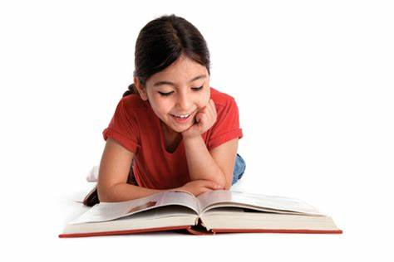
A connection is noticing how one thing is connected to another while reading!

Making Connections Text-to-Self Connection
- A connection between the text and something in your own life experience
- What does this story remind you of?
- Can you relate to the characters in the story?
- Does anything in this story remind you of anything in your own life?

Making Connections Text-to-Text Connection
- A connection between the text and another story or text that you have read previously
- What does this remind you of in another book you have read?
- How is this text similar to other things you have read?
- How is this text different from other things you have read?

Making Connections Text-to-World Connection
- A connection between the text and something that is occurring or has occurred in the world
- What does this remind you of in the real world?
- How are events in this story similar to things that happen in the real world?
- How are events in this story different from things that happen in the real world?

