Missed work for Monday March 29
Wow, what a crazy day! Six students missing then others going home in the afternoon because of the storm. Check the list to see which parts you missed.
Science – we reviewed our sound unit with Jeopardy for a quiz Wednesday
- Use the review sheet below to help you study
Christian Ethics – we learned about the resurrection
- Read Matthew 28:1-20
- Watch the 2 resurrection videos on my website in the CE section
- Write your resurrection paragraph (if you don’t have your Easter booklet at home, write it on a paper at home and then copy it into your book tomorrow at school)
Math – we learned how to do long division with bring-downs and remainders
- Watch the long division videos on my website
- Do page 2 in your division booklet (show work in booklet)
- Do page 6 in division booklet (do work in notebook, write answer in booklet)

Other
- Copy the planner notes into your planner from the photo below
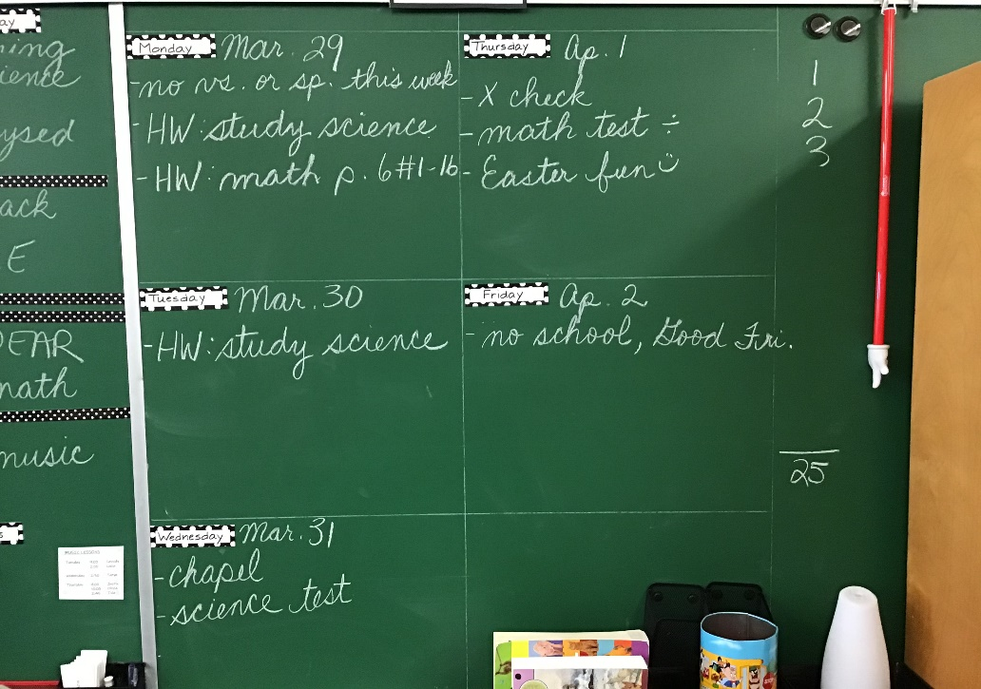
- Study for your science quiz on Wednesday

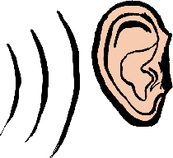
Grade 4 Science Review – Sound

What should I know?
- what sound is
- which sounds we hear (3 points)
- what a source of sound is (something that makes sound)
- examples of sources
- two kinds of sources (artificial and natural)
- how sound travels (and draw it)
- what happens to sound as it travels father from the source (and draw it)
- what pitch is
- how different pitches are made
- parts of the ear
- how we hear sounds
- the three ways instruments create sound and the names of those 3 groups
- examples of instruments in each group
- sound words : volume, pitch, waves, artificial, natural, ear drum. brain, nerves, inner ear, vibrations, etc.

