**Missed Work for Monday Feb. 8**

You may not have the materials you need to do complete everything on the list, but you do what you can.

**Science** - Finish habitat’s cover page and crossword puzzle (if you have your duotang at home)

**Physed.** - exercise for 10 minutes (you can do one of the workouts on my website if you wish

**Research Workshop**

1. write your interesting facts paragraph in your writer’s notebook
   * opening sentence, information sentences, closing sentence
   * self revise and edit it
2. have your parent mark all the corrections, then you fix them
   * bring it to school ready to do the good copy on Tuesday
3. make a cover for you research book (on a plain white piece of 8.5 x 11” computer paper)
   * look at information books you have at home to get ideas
   * include the title which will be your habitat and the author, which is you
   * include drawings or computer printed photos to make a great cover
   * pencil first then color with pencil crayon
   * you can outline with pencil crayon or skinny marker

**Math** – using “break it up” to multiply larger numbers

* think about how we used BIU to solve multiplication facts
* do Jump pages 120-121 (study the examples and grey box to help you learn)

**Word Workshop** – study the list 6 words (on the sheet I sent home with all word lists)

**Other**

* copy your planner notes from the photo below
* bring all of your work back tomorrow if you can come tomorrow
* 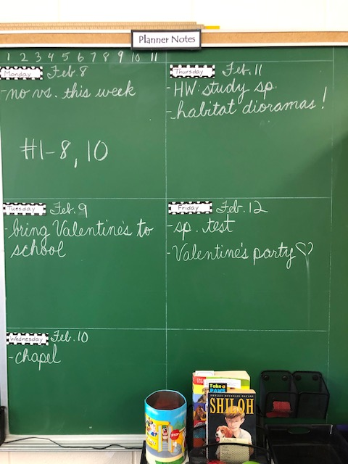make sure you get everything done (that is possible for you) so you can rejoin class learning smoothly when you return