Missed work for Monday Dec. 7
- ELA : Read for 20 minutes and tell a summary of what you read to an adult
- CE : research the 4 gospel books in your Bible and record the big ideas about the birth of Jesus from each book on the chart in your duotang. Hint : 2 of the books don’t talk about Jesus as a baby. You can start on the other activity sheets if you want to.
- Words : Go through your spelling words and look for traps and tricks
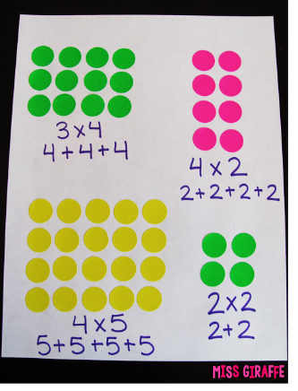
- Math : Practice drawing arrays of dots and their matching multiplication equations
  - Example

