Missed work for Monday Dec. 14
Hi Zander! Hope to see you tomorrow for a surprise substitute teacher! (I am away tomorrow)
Your HW from today…
- Copy the social notes below onto the loose-leaf paper front side
- Use a map of SK to complete scavenger hunt answers. You can write them into your duotang at recess tomorrow.
- Do cursive G page and any old corrections
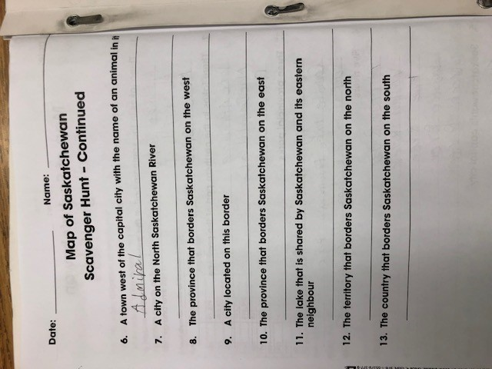
- Read for 20 minutes
- Finish Jump math book p. 96-98
- Do spelling test corrections and repeats
- Copy planner notes from photo below
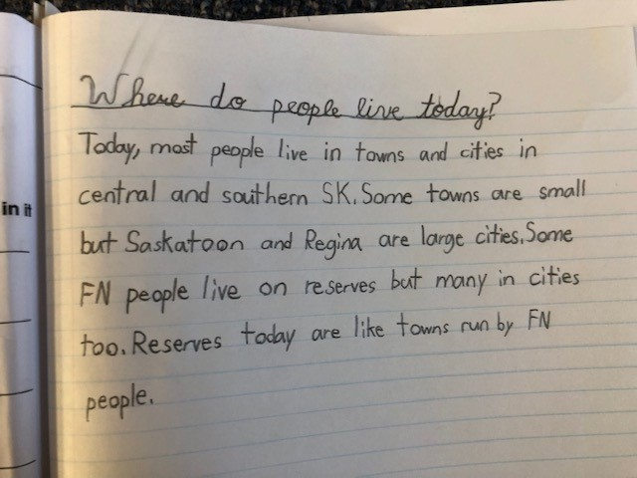
- Seesaw assignment : on your own, take a photo of you in front of your Christmas tree and send it to me on Seesaw (ask parents for help if you need it)
