Missed work for Friday March 5th…

* Social Studies – we learned about how government is paid for
  1. Read the “paying for government” pages at the bottom of this list
  2. Print off and complete the worksheet also added to this list
* Health – we did our health test on healthy eating
  1. Study for the test which you will write on Tuesday at lunch
* Math – we learned about dividing by sharing into equal groups
  1. Do Jump math book pages 135-138
* Christian Ethics – we copied some notes and started designing posters about words that heal, you will do this when you back

Other

* There is no school for kids on Monday
* We will be wrapping up more units for the second term of grade 4 so there will be a CE and social studies text next week
* See you soon!
* Don’t forget to look below for things you need for catching up

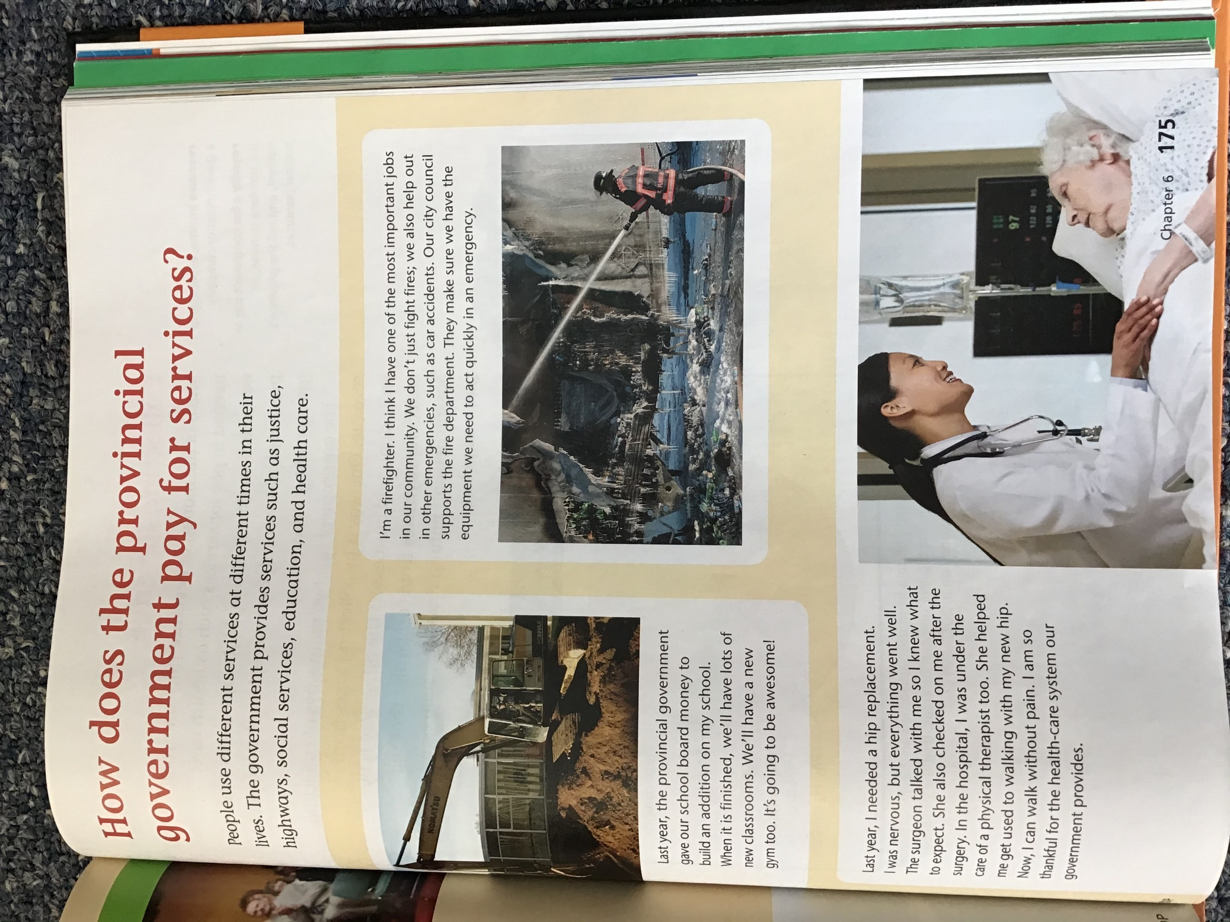 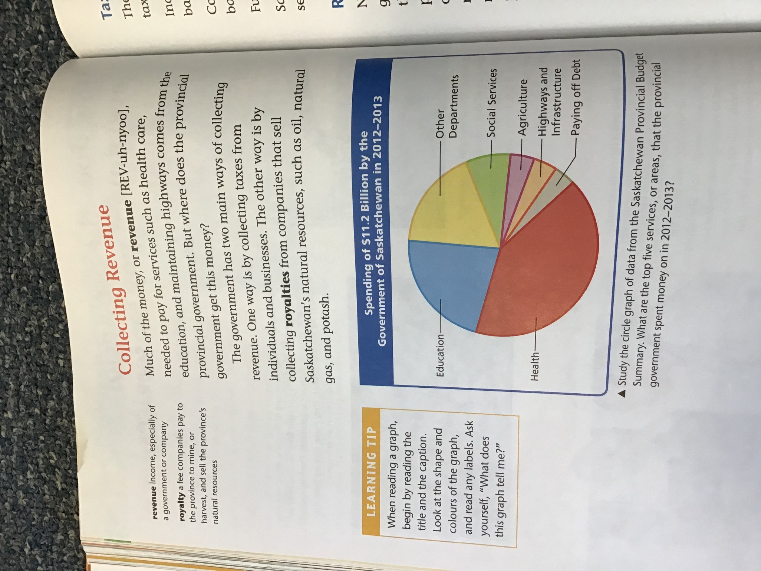 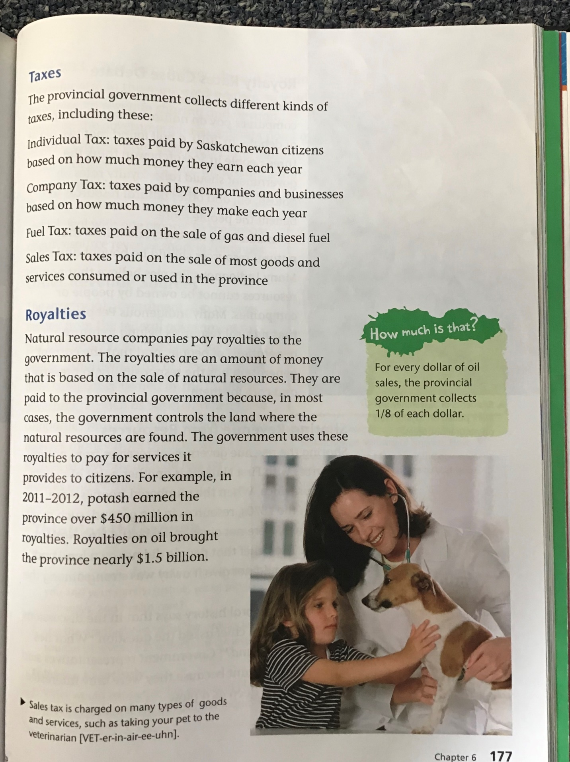 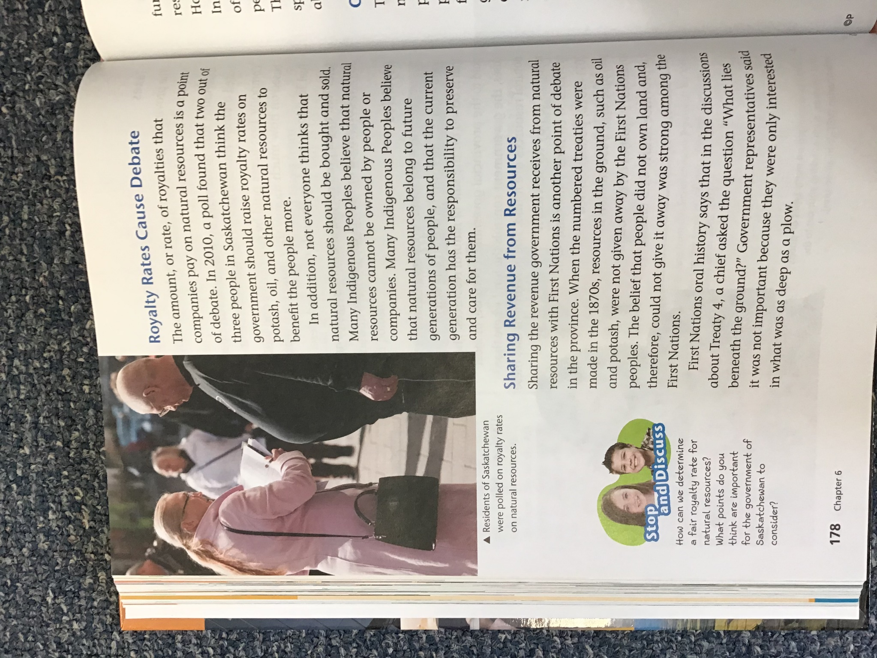 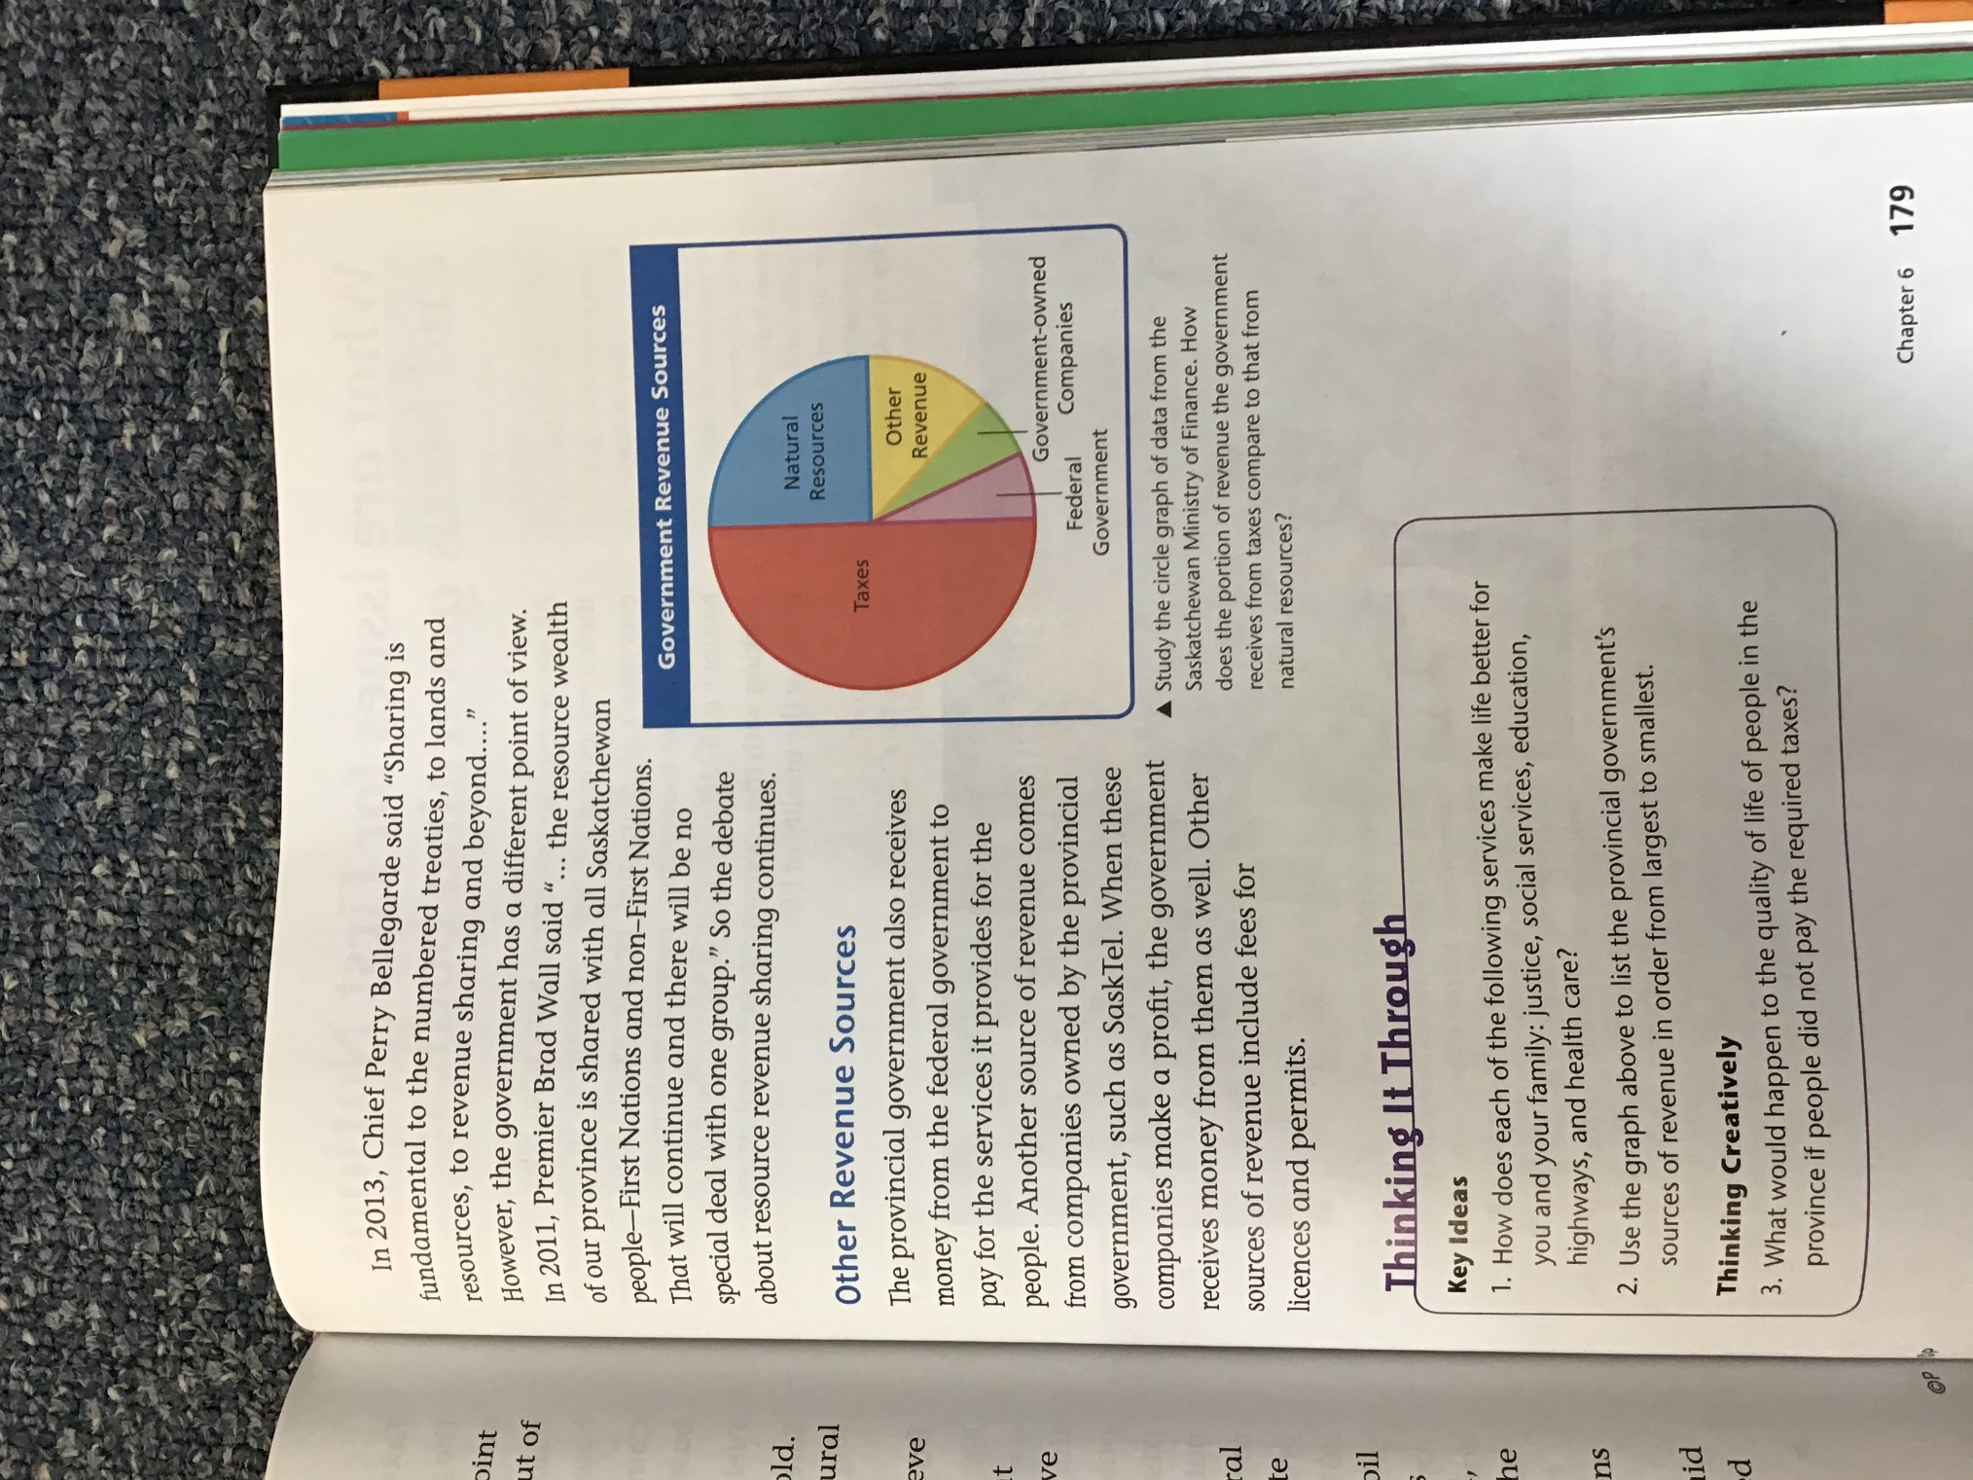

**How do we Pay for our Provincial Government?**

C:\Documents and Settings\bp712\Local Settings\Temporary Internet Files\Content.IE5\WSJQID0L\MCj04398470000[1].wmfThe government of SK spends money on things like education, building roads, agriculture and helping people in different ways like the welfare program for people without jobs. The money it spends on these things comes from taxes the people of SK pay.

**Three of these taxes are …**

1) **sales tax** – extra _________________ you pay when ___________ something new

2) **income tax** - _____________________ taken off your paycheque when you have a __________

3) **property tax** - ____________________ you pay every _________________ for the property you _____________, the bigger your __________________________ is, the more tax money you ________________

What would happen if the government quit collecting taxes? __________________________________________________________________________________________________________________________________________________________________________________________________________________________________________________________________________________________________