Missed work for Friday Feb. 26
Math – we practiced solving multiplication word problems
- Finish Jump page 132 #4-8 if you aren’t done (remember you are estimating in these)
- Do Jump page 133 #1-6 (remember to show your work and write your answer in a word sentence) *these are exact answers, not estimates
Social studies – have had a mock election for class premier today, Isla won with her campaign manager, Olivia
Christian Ethics – we learned about how God feels about us
- Copy the notes for big idea 2, from the picture below (into your duotang, under big idea 1)
- Look up the following verses in your Bible to read what God says about us
- Copy the notes for big idea 3, from the picture below
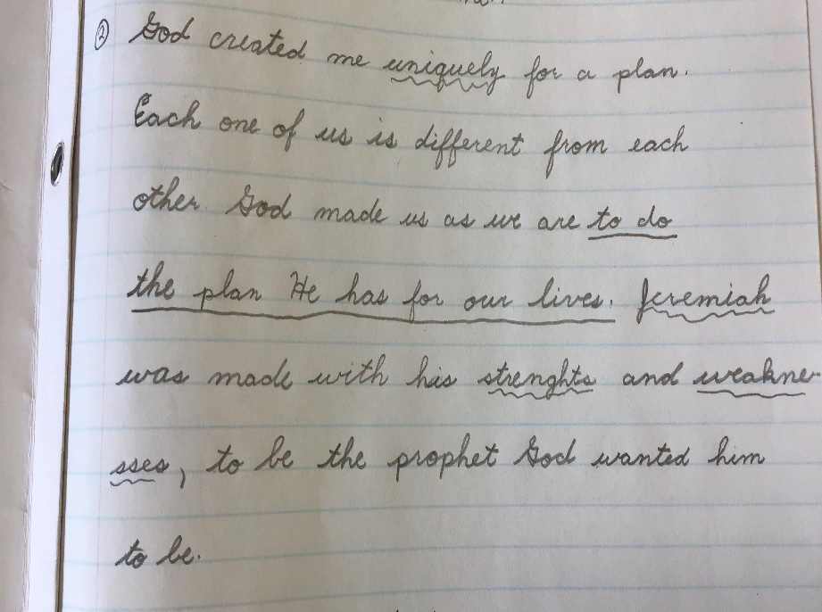
Other
- Study your verse to say on Monday
- Study your times tables for a check up on Monday

